

Comcast Video Software

OCATS Getting Started Guide

Document Status
Document Control Number:
Document Title: | OCATS Getting Started Guide
Revision History: | OCATS Getting Started Guide 0_1 (initial draft)
Date: | September 28, 2015
Status: | Draft
Distribution:
Document Status Codes:
Work in Progress (WIP) An incomplete document designed to guide discussion and generate feedback that may include several alternative requirements for consideration.
Draft (D) A document in specification format considered largely complete, but lacking review. Drafts are susceptible to substantial change during the review process.
Issued (I) A stable document which has undergone rigorous review and is suitable for product design and development. It will serve as a /basis for testing requirements.
History Information
Date | Version | Updated | Section impacted | Comments
9/28/2015 | 0.1 |  | All | Initial Draft

Author: Sajay Janardhana Kurup

Approved: _____________________

Reviewed:

Douglas Sanders ____________________
Chad Frederick____________________
Marcus Haebler____________________
Tahmina Husain__________________

Sign-off for Issue:
Douglas Sanders

Table of Contents
1 Introduction 1
1.1 Scope 1
2 OCATS UI 2
3 CATSVision 4
4 Test Scripting 5

Introduction
OCATS is comprehensive test automation framework that enables automated testing of customer premise equipment.

Scope
This document describes how to get started with OCATS after the initial server install.

OCATS UI

The OCATS UI will be available at http://<host>/CATS/settop/List.xhtml

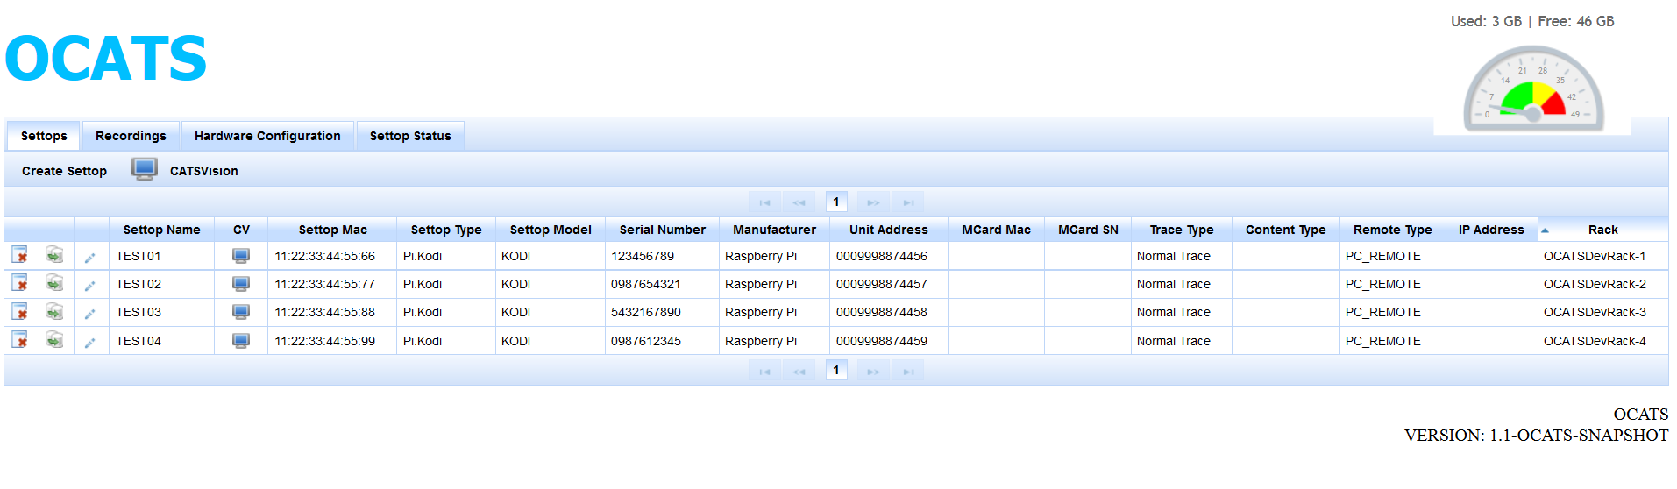
The OCATS UI is a web interface that defines and managesthe CATS Racks and the settops associated to the rack.

Rack Details as stored as part of the rackconfig.catsrack installed during the install phase. The rackconfig.catsrack is basically a yaml file that defines the rack and the different interfaces of the rack. It must be edited/extended to match the actual rack representation.

The “Hardware Configuration” Tab shows the rack view as read from the rackconfig.catsrack file.

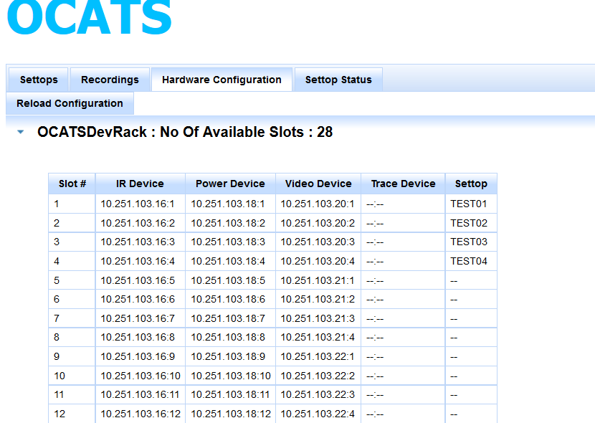

The Settops Tab maintains the settop inventory and maps which slot the settop is tied to.
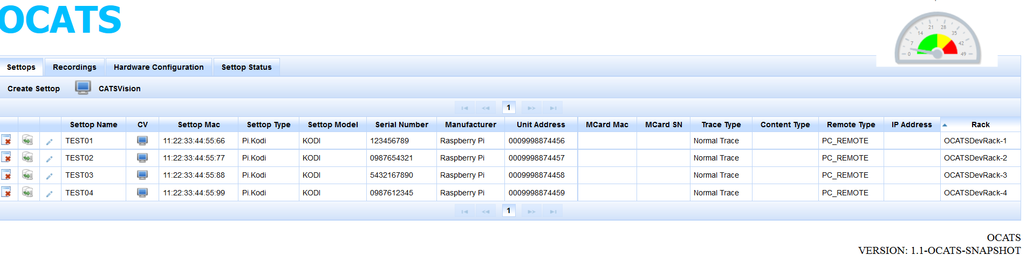

The Recordings tab allows users to start recordings of the settop video and store them into a file.

CATSVision

The CATSVision tool allows users to view and remotely control settops that are on racks. The CATSVision tool allows users to send IR, Hard Power requests to the settops and view video output from the settop. It also functions as the authoring tool for CATS where you can snap images and define regions that can be used during automation tests.

CATSVision for a settop can be launched by clicking the corresponding icon in the OCATS UI web page.
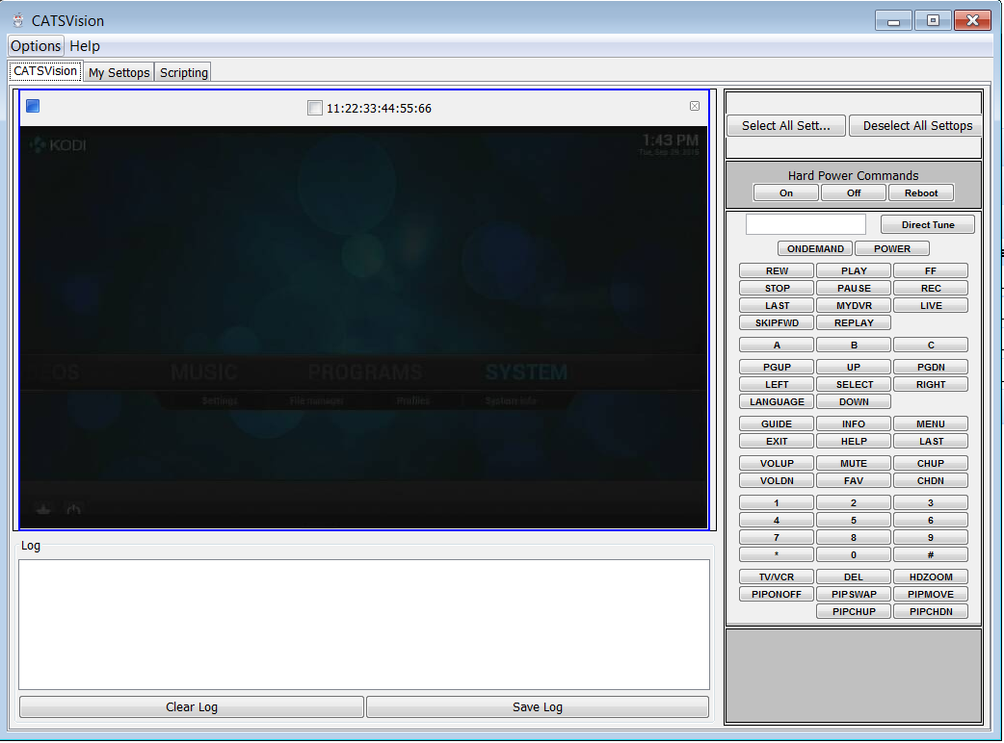

Test Scripting

To use CATS in automation test, include the following dependency into your pom.

<dependency>
<groupId>com.comcast.cats</groupId>
<artifactId>test-framework</artifactId>
<version>0.1-OCATS-SNAPSHOT</version>
</dependency>

Please note that currently the CATS artifacts are not available on an online central repository so please make sure that you have build the source and installed the artifacs into your local maven repository.

Please adjust the version above as required.

Please check the demo-test project in GutHub for a sample test script.

